Operational Plan for Eid-ul-Azha 2025
Tehsil: Kamoke

SUBMITTED BY: M/S CAIDS MARKETING NETWORK PRIVATE LTD-M/S ZAMAN TRADERS-M/S ZULFIQAR TRADERS (JOINT VENTURE)

Executive Summary

The Eid-ul-Azha Cleanliness Plan 2025, developed by M/s Caids Marketing Network Pvt. Ltd. - M/s Zaman Traders - M/s Zulfiqar Traders (JV) presents a thorough strategy to manage the significant rise in organic waste generated during the Eid-ul-Azha festivities across Kamoke tehsil in Punjab. Spanning five days from June 6 to June 10, 2025, the plan ensures uninterrupted municipal sanitation services, with a dual focus on public health and environmental safety. It includes comprehensive pre-Eid “Zero Waste Operations” to clean public spaces and prepare the environment for increased activity, followed by Eid-specific operations for timely and hygienic collection, transportation, and disposal of sacrificial waste through strategically located Temporary Collection Points (TCPs). Special sanitation measures are also implemented in all designated cattle markets, ensuring cleanliness and reducing health risks in areas of high public activity.
To reinforce public engagement, a robust communication and media campaign promotes proper waste disposal practices and community cooperation, supported by stakeholder advocacy and religious outreach. A fully operational 24/7 Monitoring and Complaint Cell provides real-time oversight and public grievance redressal, ensuring transparency and accountability. Operational support activities such as the distribution of waste bags, lime, and phenyl, installation of tents at TCPs, provision of Personal Protective Equipment (PPE), and staff welfare initiatives including lunch services, further strengthen the plan’s execution. With a strong emphasis on safety, responsiveness, and operational excellence, this plan underscores M/s Caids Marketing Network Pvt. Ltd. - M/s Zaman Traders - M/s Zulfiqar Traders (JV)’s commitment to maintaining urban cleanliness and public dignity during one of the most critical periods of the year.

Contents

- Introduction 4
  - Background 4
  - Objective 5
  - Duration of Plan 5
- Scope of Services 6
  - Cattle Market Sanitation 6
    - Daily Sweeping and Washing: 6
    - Placement of Containers: 6
    - Deployment of Resources (Manpower and Vehicles): 6
SOPs for Waste Collection and Transportation in Cattle Markets 7
  - Zero Waste Operations 7
  - Waste Collection and Transportation (Eid Days Operations) 8
Regular Operations 8
Eid Specific Operations 8
SOPs for Ijtamai Qurban Gah 9
Deployment of Machinery 11
Tehsil Wise Deployment of Machinery 12
Total Deployment of Machinery (Tehsil Wise) 12
- Disposal Sites 13
- Camps on Eid ul Azha 15
- Communication and Media Plan 16
  - Campaign Objective 16
  - Campaign Goal: 16
  - Target Audience 16
  - Campaign Components 16
- Monitoring and Complaint Cell Working 18
- Human R2esource Management for Eid-ul-Azha Operations 19
  - Workforce Deployment 19
  - Shift Management and Attendance 19
  - Worker Safety 19
  - Compliance by Contractors 19
- Administrative Work on Eid ul-Azha 21
  - Lunch for Employees 21
  - Camps Installation and Removal 21
  - PPE Provision 22
  - Provision of Waste Bags 22
  - Provision of Lime and Phenyl 22
  - Tents for Temporary Collection Points (TCPs) 22
SOPs for Temporary Waste Collection Points 23
Annexure 1: Locations of Cattle Market and Deployment of Resources 24
Annexure 2: The estimated number of Qurbani 25
Annexure 3: Estimated numbers of Ijtamai Qurbani 26
Annexure 4: The detailed table of TCP 27
Annexure 5: Location of Camps and Duty Roster 28
List of Commercial Markets 29
List of Masajid & Eid Gahs 30
List of Graveyard 31
Contact Detail of Concern Official 33
List of Senior Management 34

INTRODUCTION
Eid-ul-Azha, celebrated annually on the 10th of Dhu al-Hijjah, holds great religious and cultural significance for Muslims across the globe. While the celebration is spiritually meaningful, it also brings about a substantial increase in solid waste, especially organic waste such as animal offal, blood, and waste from packaging and fodder. Improper handling and disposal of this waste can pose serious public health risks, environmental hazards, and cause social discomfort if not managed properly.
The Eid plan has been formulated in consultation with local stakeholders, incorporating operational data from previous Eid campaigns, current municipal needs, and the anticipated increase in animal sacrifices. It outlines the deployment of manpower and machinery, setup of temporary collection points, distribution of waste bags, enhanced disposal mechanisms, and community awareness drives. Real-time monitoring, complaint management, and environmental safeguards are also integrated into the strategy to ensure timely service delivery and public satisfaction.
This plan not only ensures uninterrupted municipal sanitation services during the Eid holidays but also reinforces M/s Caids Marketing Network Pvt. Ltd. - M/s Zaman Traders - M/s Zulfiqar Traders (JV) commitment to maintaining cleanliness, protecting public health, and upholding the dignity of urban living during one of the busiest and most sensitive periods of the year.

Background
M/s Caids Marketing Network Pvt. Ltd. - M/s Zaman Traders - M/s Zulfiqar Traders (JV)under the umbrella of Daewoo Pakistan Express Bus Service Ltd., has been awarded the contract for the provision of integrated solid waste management services in Kamoketehsil across Punjab under the Suthra Punjab Program. The scope of work awarded to M/s Caids Marketing Network Pvt. Ltd. - M/s Zaman Traders - M/s Zulfiqar Traders (JV) encompasses all core components of municipal waste management, including door-to-door collection, street sweeping, secondary transportation, waste disposal, and special cleanliness measures during public events and religious festivals.
In line with the Terms of Reference (TORs) of the contract and the requirements set forth in the bidding documents, Caids Marketing holds the explicit responsibility of ensuring comprehensive cleanliness operations during special events, including Eid-ul-Azha. Recognizing the significant increase in organic waste generation during Eid-ul-Azha—primarily in the form of sacrificial animal offal, blood, hides, and packaging waste— M/s Caids Marketing Network Pvt. Ltd. - M/s Zaman Traders - M/s Zulfiqar Traders (JV) has developed a detailed operational plan to address the heightened sanitation needs of this period.
This Eid-ul-Azha Cleanliness Plan 2025 outlines the strategic deployment of resources and execution framework to ensure efficient and hygienic collection, transportation, and disposal of waste generated during the Eid holidays. The plan also integrates community engagement, real- time complaint management, public awareness campaigns, and strict health and safety protocols to safeguard both the environment and public health.

Objective
The objective of this plan is to ensure the timely and hygienic collection of sacrificial animal waste during Eid-ul-Azha through dedicated field teams and deployment of necessary machinery. It also includes the establishment of Temporary Collection Points (TCPs) across Kamoke tehsil for efficient waste handling, along with the activation of a dedicated complaint and monitoring cell to oversee operations and promptly address public concerns.

Duration of Plan
The Eid-ul-Azha Cleanliness Plan 2025 will be implemented over a five-day period, from June 6 to June 10, 2025, covering the days immediately preceding Eid and the three days of Eid-ul-Azha itself.

Days | June 6 | June 7 | June 8 | June 9 | June 10
Pre Eid
Eid Days
Post Eid

Note: The activities to be performed are mentioned in subsequent section of the report.

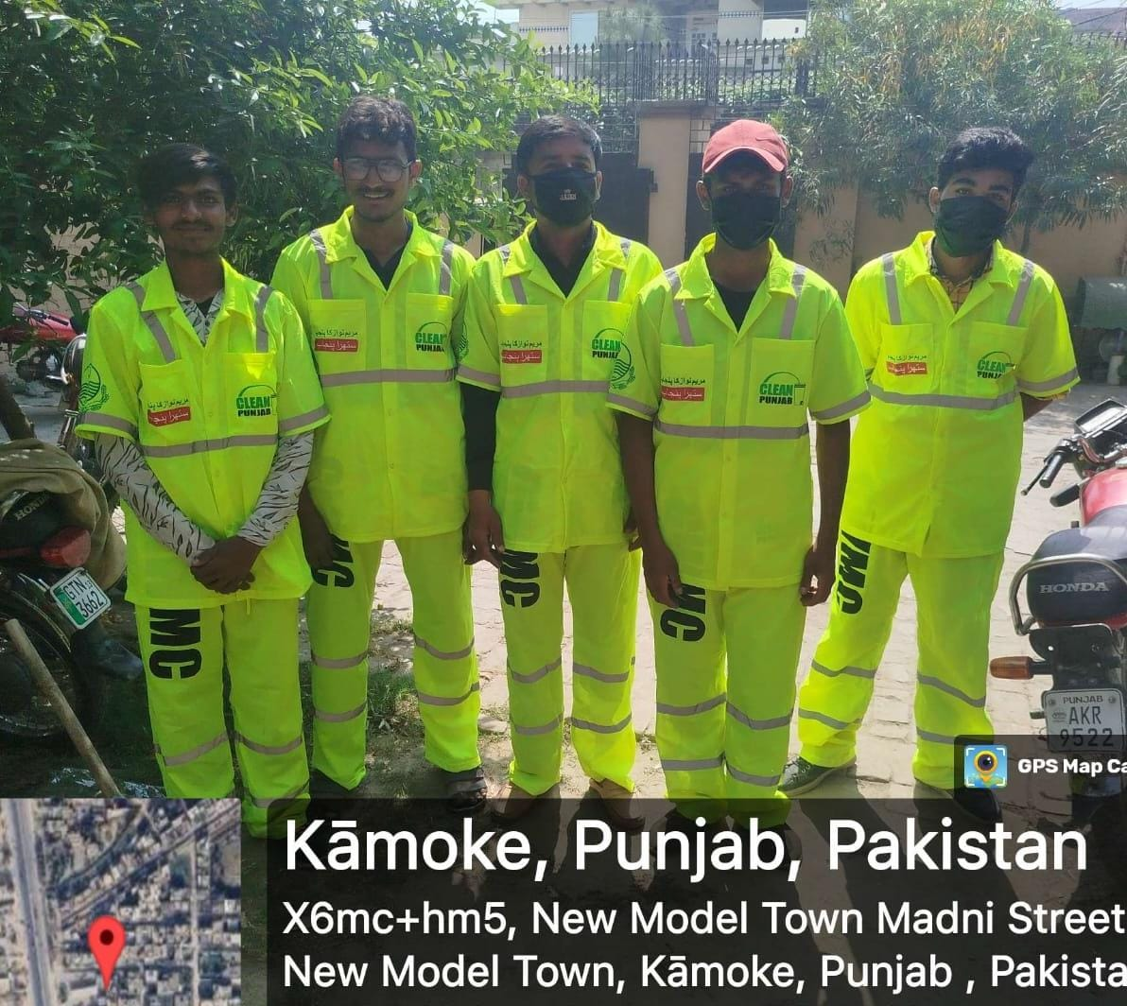

SCOPE OF SERVICES
To ensure a clean and hygienic environment during Eid-ul-Azha, M/s Caids Marketing Network Pvt. Ltd. - M/s Zaman Traders - M/s Zulfiqar Traders (JV) will execute a comprehensive set of solid waste management services across Kamoketehsil under its operational control. These services are designed to address both regular municipal waste and the surge in organic waste generated from sacrificial activities. The plan is structured to cover pre- Eid preparations, activities during Eid days, and post-Eid recovery operations.

Cattle Market Sanitation
M/s Caids Marketing Network Pvt. Ltd. - M/s Zaman Traders - M/s Zulfiqar Traders (JV) will implement special sanitation measures in all officially designated cattle markets falling within its Kamoketehsil of operation. These measures are designed to maintain cleanliness, reduce health risks, and ensure an overall hygienic environment in areas where a high influx of livestock and public gatherings is expected in the days leading up to Eid- ul-Azha.
The following activities will be carried out:

Daily Sweeping and Washing:
Continuous sweeping and washing operations will be conducted in all active cattle markets to remove solid waste, animal droppings, and other organic matter. The frequency of these operations will be increased during peak days.

Placement of Containers:
Existing municipal containers will be placed strategically within and around the cattle market premises for interim storage of waste. In areas where containers are not feasible, waste will be collected and transported directly to Temporary Collection Points (TCPs).

Deployment of Resources (Manpower and Vehicles):
Sanitary workers will be deployed in shifts to ensure round-the-clock cleaning operations. Waste transportation vehicles, such as mini dumpers, loader rickshaws, and tractor-trolleys, will be assigned to each cattle market to ensure immediate waste removal.
As part of its Eid-ul-Azha preparedness, M/s Caids Marketing Network Pvt. Ltd. - M/s Zaman Traders - M/s Zulfiqar Traders (JV) has rolled out a comprehensive sanitation strategy to maintain cleanliness across all designated cattle markets within its service areas. Resources including sanitary workers, transportation vehicles, and waste containers (already available/existing) will be strategically deployed. Sanitary workers will carry out on-site sweeping and manual waste collection, while transportation vehicles will either transfer the waste to nearby containers or directly to TCPs established for Eid operations.

The proposed number of sanitary workers and vehicles allocated to each cattle market is detailed in Annexure 1. Collectively, these measures aim to ensure a clean and hygienic environment for vendors, buyers, and the surrounding community, while mitigating any associated public health risks and environmental nuisances.

SOPs for Waste Collection and Transportation in Cattle Markets

Activity performed | Timeline | Responsibility | Monitoring
Arrangements for machinery, containers,  hand carts | Upon establishment of markets | - AM Ops | - TM  - DM
Establishment of  awareness camps at each market. |  | - A&F  - AM Ops | - Manager Communication  - TM
Availability of awareness material, banners etc. |  | - A&F  - Manager Admin | - Manager communication  - TM
Deployment of workers with PPEs during all days |  | - Supervisor  - AM Ops | - TM  - DMs
Sprinkling and timely lifting of containers | In three shifts
Getting contact details of the person buying animal & distribution of  awareness material & bags |  | - Social mobiliser/staff deputed. | - AM Communication  - TM
Note: Divisional manager will be in-charge of above activities.

Zero Waste Operations
In accordance with the Eid-ul-Azha Cleanliness Plan, M/s Caids Marketing Network Pvt. Ltd. - M/s Zaman Traders - M/s Zulfiqar Traders (JV) will undertake a comprehensive Zero Waste Operation across Kamoketehsil to ensure a clean and sanitary environment prior to the commencement of sacrificial activities. This special operation is scheduled for completion by 10:00 PM on June 6, 2025, the night before Eid-ul-Azha, and will serve as a foundational activity to support efficient offal collection during the Eid days.
The operation will be conducted in two shifts per day, with enhanced field presence of sanitary workers, supervisors, and mechanical support. Cleaning efforts will be focused on;
- All major and internal roads
- Commercial markets
- Residential neighborhoods Open plots
- Areas surrounding containers
- Eid Gahs.

The objective is to ensure that no visible waste remains in public spaces, thereby minimizing the risk of environmental pollution and health hazards once sacrificial activities begin.
To support this initiative, a combination of manual sweeping, mechanical sweeping (where applicable), container clearance, and waste removal using mini-tippers, loader rickshaws, and other dedicated vehicles will be deployed. Supervisory staff will monitor the field teams in real- time, ensuring compliance with assigned routes and timelines. Pictorial evidence, route clearance logs, and staff performance reports will be submitted to the central Monitoring Cell for documentation and quality assurance.
This Zero Waste Operation is critical for establishing sanitary conditions and public confidence in the days leading up to Eid, setting the stage for successful execution of the main Eid waste management operations.

Waste Collection and Transportation (Eid Days Operations)
During the Eid-ul-Azha holidays, M/s Caids Marketing Network Pvt. Ltd. - M/s Zaman Traders - M/s Zulfiqar Traders (JV) will carry out two parallel streams of waste management operations across Kamoke tehsil under its jurisdiction to ensure uninterrupted municipal services as well as efficient handling of sacrificial waste.

Regular Operations
The first stream involves regular operations, which will continue as per the routine daily schedule defined in the contract. These services include sweeping of roads, door-to-door collection of household waste, container clearance, and washing of public spaces such as markets, roadsides, residential colonies, hospitals, bus terminals, and Eid Gahs. All routine operations will be conducted in two shifts, with supervisory and monitoring staff deployed in each tehsil to ensure timely execution and service quality. Transport vehicles and backup machinery will be kept available to support these ongoing municipal functions. Special focus will be maintained on high- traffic areas and sensitive urban zones to preserve public hygiene and prevent any lapse in routine cleanliness standards during the festive period.

Eid Specific Operations
The second stream relates to Eid-specific operations focusing on the collection and transportation of animal waste generated from sacrificial activities. This component involves both primary and secondary collection systems, beginning with the collection of offal from doorsteps and slaughter points and its delivery to the designated Temporary Collection Points (TCPs). From there, the waste will be lifted and transported to officially approved dumpsites for final disposal using appropriate machinery and transport vehicles. The estimated number of Qurbani is given in Annexure 2: and estimated numbers of Ijtamai Qurbani is given in Annexure 3.
Decorated gates adorned with flowers will be placed outside mosques and Eid Gahs to warmly welcome the public attending Eid prayers

SOPs for Ijtamai Qurban Gah

Activities performed | Timeline | Responsibility | Monitoring
Coordination with focal person of Qurban gah for offal collection  arrangements | 3 days before Eid | - A&F  - AM Ops | - TM  - DM
Deployment of designated machinery at  Ijtami Qurban Gahs during first day of Eid. | 4 AM - 6 PM
Deployment of designated machinery at Ijtami Qurban Gah during 2nd and 3rd  day of Eid | 5 AM - 5 PM
Deployment of sanitary staff with proper uniform and safety gadgets. 2  sanitary workers will be engaged at each Qurban Gah | During all Operational days of Eid | Concerned Sanitary Supervisor | - Zonal Officers  - AMs/DMs/TMs
Digital monitoring of all operational activities (incoming and outgoing) at Ijtami Qurban Gah by uploading  photographs |  | - AM Ops | - Manager Monitoring
Waste/ Offal collected from Ijtami Qurban Gahs will be transported to  nearby waste collection point. |  | Concerned Sanitary Supervisor/ AM Ops | - AM Ops  - TM
Note: Divisional manager will be in-charge of above activities.

Primary Collection of Offal
For effective management of sacrificial waste during Eid ul-Azha, the M/s Caids Marketing Network Pvt. Ltd. - M/s Zaman Traders - M/s Zulfiqar Traders (JV) has ensured a well-organized primary collection system for offal. Key resources such as loader rickshaws and pickups are made readily available to facilitate prompt collection directly from neighborhoods and streets.
Each operational unit is supervised by trained personnel who possess detailed knowledge of local qurbani activities within their designated areas. This enables supervisors to proactively monitor high-volume zones and coordinate efficient offal collection in real time. The goal is to minimize waste accumulation at the source and ensure rapid transportation to Temporary Collection Points (TCPs), thereby maintaining cleanliness and public health standards during the Eid festivities.

Secondary Waste Transportation on Eid Days
During Eid ul-Azha, M/s Caids Marketing Network Pvt. Ltd. - M/s Zaman Traders - M/s Zulfiqar Traders (JV) ensures the smooth and timely secondary transportation of sacrificial waste from Temporary Collection Points (TCPs) to designated dumpsites. This stage is crucial for maintaining hygiene and preventing waste accumulation in residential and commercial areas.

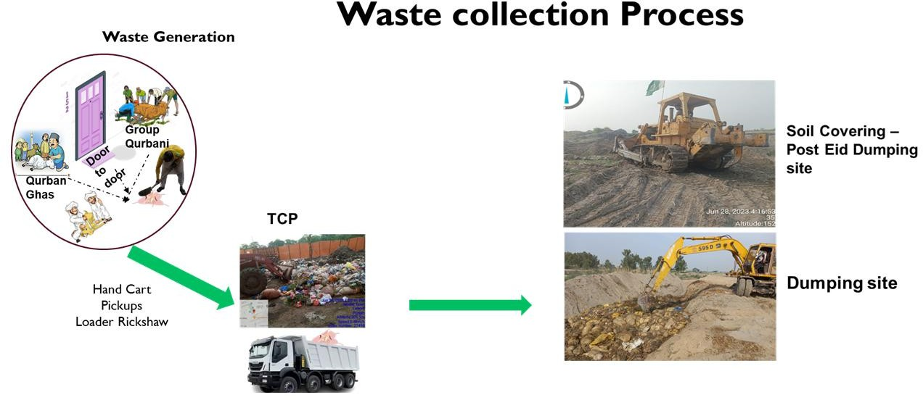
Temporary Collection Points (TCPs) serve as interim waste hubs where offals collected from various neighborhoods are temporarily stored before final disposal. Each TCP is equipped with operational tents to support field staff and manage vehicle flow.
TCP placement is strategically planned based on population density, urban layout, and proximity of Union Councils (UCs). Typically, one TCP caters to 2 UCs, though this number may vary depending on local conditions and accessibility.
To manage the transportation of waste from these TCPs to officially approved dumpsites, the following machinery and vehicles are deployed:

- Tractor Trolleys
- Dumpers
- Excavators (for heavy lifting and loading operations)

All TCPs are scheduled for same-day clearance to prevent environmental hazards, unpleasant odors, and health risks. This efficient secondary transport system ensures a clean and safe environment is maintained throughout the Eid festivities. The detailed table of TCP is given in Annexure 4:

Deployment of Machinery

SOPs for the Machinery at Temporary Waste Transfer Station

SN |  | Activity performed | Timeline | Responsibility | Monitoring
1 | Arrival of machinery at dedicated collection points. |  | 5 am during Three days of Eid. | - AM Ops  - A&F | - TM  - Admin Manager
2 | Ensuring the presence of machinery in the field |  | During all operational days of Eid
Note: Divisional manager will be in-charge of above activities.




Plan of Eid ul Azha 2025
By
M/s Caids Marketing Network Pvt. Ltd. - M/s Zaman Traders - M/s Zulfiqar Traders (JV)

Tehsil Additional Wise Deployment of Machinery

 | Day 1 |  |  | Day 2 |  |  | Day 3
Tehsil Name | Total Pickups / Rickshaw | Total Dumper  / Trolly | Total Excavators | Total Pickups / Rickshaw | Total Dumper  / Trolly | Total Excavators | Total Pickups / Rickshaw | Total Dumper  / Trolly | Total Excavators
Kamoke | 75 | 15 | 3 | 75 | 15 | 3 | 19 | 4 | 1

Total Additional Deployment of Machinery (Tehsil Wise)

Tehsil Name | Total Pickups / Rickshaw | Total Dumpers / Trolly | Total Excavators
Kamoke | 75 | 15 | 3

DISPOSAL SITES
To ensure environmentally responsible waste management during Eid ul-Azha, M/s Caids Marketing Network Pvt. Ltd. - M/s Zaman Traders - M/s Zulfiqar Traders (JV) utilizes designated disposal sites for the safe and hygienic dumping of offal and sacrificial waste. These sites are officially approved locations that meet environmental and health standards to prevent contamination and public nuisance. All waste collected from temporary collection points (TCPs) is transported to these sites using dumpers, loaders, and other heavy machinery. Special arrangements, including lime spreading and daily waste coverage, are carried out to control odor and pest activity. Continuous monitoring is maintained to ensure that disposal operations are conducted in a controlled and efficient manner, minimizing environmental impact during the Eid celebrations.

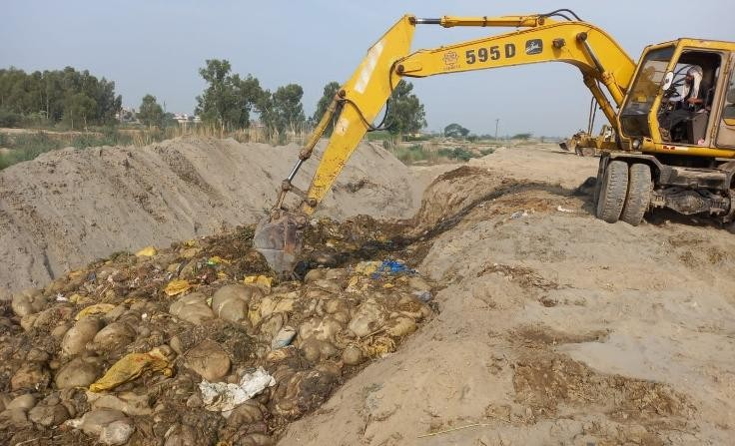

SOPs for Waste Disposal at Dumpsite
To ensure proper handling and final disposal of sacrificial waste during Eid ul-Azha, M/s Caids Marketing Network Pvt. Ltd. - M/s Zaman Traders - M/s Zulfiqar Traders (JV) will implement the following Standard Operating Procedures at all designated dumpsites:

Designated Dumpsite Preparation
  - Only officially approved and environmentally safe dumpsites are to be used.
  - Access roads must be cleared and leveled before Eid to facilitate the movement of heavy vehicles.
  - Signage and safety boundaries to be installed around each site.

Waste Reception & Management
  - All waste from Temporary Collection Points (TCPs) to be transported to dumpsites without delay.
  - Vehicles (dumpers, trolleys, pickups) will offload waste in pre-allocated sections.
  - Excavators and loaders will be used to spread, level, and compact waste to prevent piling and overflow.

Disinfection & Environmental Safety
  - After each unloading cycle, lime powder or disinfectant must be applied to control odor and bacterial spread.
  - Regular spraying of anti-germ and anti-odor chemicals across the dumpsite area.
  - Immediate action to be taken to prevent water stagnation or fly/mosquito breeding.

PPE & Worker Safety
  - All personnel on-site must be equipped with proper Personal Protective Equipment (PPE): gloves, boots, masks, and reflective vests.
  - Provision of drinking water, rest area, and first aid at each dumpsite.
  - Site supervisors to enforce safety protocols strictly.

Documentation & Monitoring
  - Maintain logs of:
    - Number of trips received
    - Approximate quantity of waste dumped
    - Machinery and manpower deployed
  - Supervisors will report to the central Monitoring Cell for real-time coordination and updates.
  - Daily photos or digital evidence to be shared for transparency and record-keeping.

Final Closure & Site Restoration
  - After the completion of Eid operations:
  - Waste to be covered with soil or other material
  - Site to be leveled and disinfected
  - Final inspection to ensure environmental compliance and cleanliness

SN | Activity performed | Timeline | Responsibility | Monitoring
1 | Deployment of supervisory staff | 6th June, 2025 | - TM  - AM  - A&F | - Manager Landfill
2 | Arrangement of soil for capping of waste |  |  | - Manager Landfill  - Manager Admin
3 | Arrangements of police to avoid scavengers |  |  | - TM  - Manager Landfill  - Manager Admin
Note: Divisional manager will be in-charge of above activities.

CAMPS ON EID UL AZHA
During Eid ul-Azha, the M/s Caids Marketing Network Pvt. Ltd. - M/s Zaman Traders - M/s Zulfiqar Traders (JV) sets up special camps in strategic locations across its service areas to enhance waste management services. These camps serve as both control points for staff coordination and help desks for the public, where citizens can receive information and register complaints related to cleanliness and waste management. Each camp is staffed with trained personnel and equipped with necessary tools to monitor field activities and ensure quick responses to any issues. To facilitate better communication and visibility, banners, standees, complaint registers, and other required materials will be placed at each Eid camp. The camps are strategically located to busy roads, and densely populated areas to ensure efficient and timely waste management throughout the Eid holidays. Detail and locations of camps are available in Annexure 5:
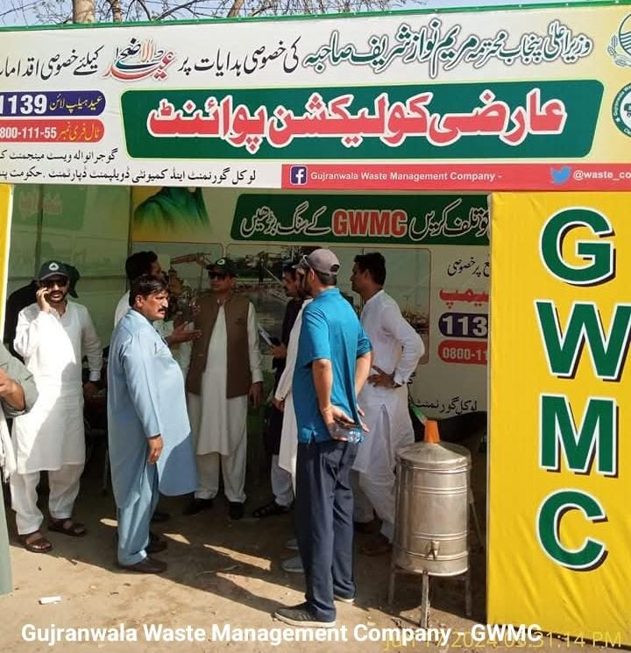

COMMUNICATION AND MEDIA PLAN

Campaign Objective:
Bakra Eid (Eid-ul-Azha) is a time of heightened waste generation due to animal sacrifices, with offal, blood, hides, and packaging material requiring urgent and efficient disposal. Improper waste handling during this period leads to environmental, health, and sanitation challenges. For a brand like M/s Caids Marketing Network Pvt. Ltd. - M/s Zaman Traders - M/s Zulfiqar Traders (JV)this is a critical window to showcase its capability, responsiveness, and public service role.

Campaign Goal:
- Promote public awareness about proper waste disposal practices during Eid.
- Strengthen brand trust by showcasing proactive services and response time.
- Educate citizens on hygiene, safety, and collaboration with waste teams.
- Reinforce Daewoo’s identity as a modern, reliable, and community-focused service provider.
- Appeal for public cooperation and Testimonial

Target Audience
- Primary: Urban residents in service areas
- Secondary: Local government, civic influencers, youth groups, and media

Campaign Components

Social Media Campaigns
  - Ads Budget: PKR 400,000
  - Daily reels, Eid messages, and Caids waste management working

Outdoor Media Inventory (Per Tehsil)

Media Type | Quantity | Purpose
Awareness camps (Division/district/tehsil) | 6 | Physical setups in marketplaces and other areas. Act as a public touchpoint to humanize the campaign.
Screen-Printed Cloth Banners | 200 | Installed at high-traffic areas (mandis, chowks, near mosques) to ensure visibility in urban and rural settings. Durable and cost-effective.
Brochures (Eid+ Generalize) / Pamphlets | 10,000 | Distributed hand-to-hand in markets, door-to-door, and via mosque committees to inform citizens about proper waste disposal methods and helpline numbers.

Flexes (Eid+ Generalize) | 20+15 | Strategic placement at entry/exit points of towns, cattle markets, and union council offices to establish brand presence and educate the masses.
Posters | 300 | Placed in local shops, health units, and on walls of visible public spots to enhance repetition and awareness.

Community & Religious Engagement
  - White Paper Mosque Pamphlets: Distributed before Eid prayers as per need
  - Leaflets & Door-to-Door Campaign: Distribution 1–2 days before Eid in target areas.

Print Media

  - Newspaper Ads Budget: 1.5 million

Mainstream Media
  - Cable adds run at 80,000 pkr
  - City 42, City 41, Rohi TV Ads & other media channels ads Budget:1.5 million
  - Seminars with City and the Jang

Stakeholder Advocacy
  - Meetings with local stakeholders from the advocacy point of view
  - Recording of messages for social media platforms
  - Gain their support for public awareness and public cooperation.

Monitoring & Evaluation
  - Call logs (waste pickup requests)
  - Cleanliness level tracking (before/after photos)
  - Social media analytics and complaints
  - Feedback from UCs and stakeholders
  - Testimonials from the field

MONITORING AND COMPLAINT CELL WORKING
During Eid ul-Azha, the M/s Caids Marketing Network Pvt. Ltd. - M/s Zaman Traders - M/s Zulfiqar Traders (JV) operates a fully functional Monitoring and Complaint Cell that works 24 hours a day throughout the Eid holidays to ensure the smooth execution of the sanitation plan and prompt resolution of public concerns. The Monitoring Cell actively supervises field operations in real-time, ensuring the efficient collection of offal, timely waste transportation, and overall cleanliness across all service areas. It maintains close coordination with field staff, Eid camp in-charges, and supervisory teams to ensure all tasks are carried out according to the operational schedule.
At the same time, the Complaint Cell remains fully active around the clock during Eid, managing public complaints through direct calls, on-ground camps, and the Suthra Punjab Portal. Each complaint is properly logged, tracked, and monitored through the portal to ensure transparency and swift action.



7 HUMAN RESOURCE MANAGEMENT FOR EID-UL- AZHA OPERATIONS
Effective human resource deployment is a cornerstone of the Eid-ul-Azha Cleanliness Plan. M/s Caids Marketing Network Pvt. Ltd. - M/s Zaman Traders - M/s Zulfiqar Traders (JV) has developed a comprehensive HR framework to ensure uninterrupted service delivery, strict oversight, and operational efficiency across Kamoketehsil during the Eid period.

Workforce Deployment
    - Sanitary Workers: A large number of sanitary workers will be deployed in two shifts (morning and night) to ensure continuous cleanliness before, during, and after Eid.
    - Camp In-Charges: Every camp and Temporary Collection Point (TCP) will have an supervisor responsible for managing the workers, machinery, and coordination with the public.

Shift Management and Attendance
    - Shift Scheduling: Head office and field staff will work in two overlapping shifts — morning and night — to make sure cleanliness work continues without any breaks.
    - Attendance Checking: Attendance will be marked through biometric and PITB Portal. Also monitor the teams by doing random checks in the field to confirm staff presence.

Worker Safety
    - PPE Provision: All operational staff will be equipped with full PPE kits, including gloves, masks, reflective vests, boots, and hand sanitizers.

Compliance by Contractors
To ensure the successful execution of Eid operations, strict compliance from all private contractors will be enforced, particularly in the following areas:
    - Human Resource Provision: Contractors are required to provide the agreed number of skilled manpower (sanitary workers, supervisors, drivers) as per contractual obligations.
    - Machinery Mobilization: Timely availability of loaders, dumpers, rickshaws, water tankers, and other support machinery must be ensured by the contractors in each tehsil with the coordination with the Admin & Finance (A&F) team to ensure operational effectiveness.

    - Weighbridge Operations: Accurate tracking and documentation of waste tonnage via weighbridges must be carried out in coordination with the Admin & Finance (A&F) team to ensure operational transparency and billing accuracy.
To ensure smooth and uninterrupted operations during the Eid-ul-Azha holidays, the HR department will issue official letters at least 15 days before Eid to the following key stakeholders.
    - Contractor of Sanitary Workers
    - Contractor of Machinery
    - Weighbridge Staff and Owner

Each letter will clearly outline performance expectations, operational timelines, and assigned responsibilities. Failure to meet any of the commitments outlined in the letters, such as insufficient staff, unavailability of machinery, or disruption in weighbridge services may result in penalties, contract escalation, deduction in payments, or legal action as per the terms of the agreement.

ADMINISTRATIVE WORK ON EID UL-AZHA
To ensure the successful execution of the sanitation plan during Eid ul-Azha, M/s Caids Marketing Network Pvt. Ltd. - M/s Zaman Traders - M/s Zulfiqar Traders (JV) carries out several vital administrative activities that provide operational support and ensure workforce readiness. These tasks include:

Lunch for Employees
Arrangements are made to provide timely lunch to all field staff, supervisors, and support personnel working during Eid days. This initiative ensures staff well-being and keeps morale high during long and demanding work shifts.

Camps Installation and Removal
Dedicated teams are deployed for the setup of Eid camps at key locations before operations begin. These camps serve as field control points and public facilitation centers. After the completion of Eid duties, the same teams handle the systematic removal and cleanup of all camp setups. Location of Camps are given in Annexure:

Responsibilities of Camps

Activities performed | Timeline | Responsibility | Monitoring
Establishment of awareness camp. | Two days before Eid | - A&F  - AM Ops  - Supervisor | - TM  - Admin Manager  - Manager Communication
Availability/distribution of garbage bags, complaint register and required stationery and furniture at camps. | During all  operational days | - A&F  - AM Admin  - AM Ops | - TMs  - Manger Admin  - DMs
Availability of awareness material at the camp. |  | - AM  communication  - AM Ops | - Manager Communication  - Manager HR
Presence of staff for social mobilization and awareness.
Complaints escalation to concerned staff. |  | - Social mobilize or staff deputed | - TMs  - Ams  - DMs
Proper record maintenance regarding complaints and garbage bags distribution.
Camps Operational timing | - 6 am to 8 pm (3 days of Eid)  - 8 am to 5 pm | - AM  Communication  - Supervisor  - TM/AM | - Manager Communication  - Manager HR  - TM/AMs/DMs

(2 days before
Eid)
Note: Divisional manager will be in-charge of above activities.

PPE Provision
Personal Protective Equipment (PPE), including gloves, face masks, safety vests, boots, and sanitizers, is provided to all on-ground staff to ensure safety, hygiene, and compliance with health protocols throughout the Eid operations.

Provision of Waste Bags
Waste bags are distributed to citizens, particularly in residential and high-slaughter areas, to encourage proper disposal of offal and animal waste. These bags are also supplied to field workers for efficient waste collection and handling.
Detail of Distribution of Bags are as follow:

Tehsil | Small Bags 30x36 (40%) | Large Bags 35x44 (60%) | Total Bags
Kamoke | 2,800 | 4,200 | 7,000

Provision of Lime and Phenyl
Lime and phenyl are supplied in sufficient quantities for use at slaughter points and waste collection areas. These materials help control odor, prevent insect breeding, and maintain sanitary conditions during and after waste removal activities.

Tehsil | Total Lime (KGs) | Total Phenyl (Ltrs) | Rose Water (Ltrs)
Kamoke | 5,000 | 200 | 40

Tents for Temporary Collection Points (TCPs)
Tents are installed at designated Temporary Collection Points (TCPs) to provide shade and shelter for staff and temporary storage of waste. These tents also help identify key waste disposal locations for the public and protect materials and workers from weather exposure.

SOPs for Temporary Waste Collection Points

SN | Activities performed | Timeline | Responsibility | Monitoring
1 | Establishment of collection point | One day before Eid day | - A&F  - AM Ops  - Supervisor | - TM  - DM
2 | Deployment of designated machinery at collection point  during Eid Days | During all Eid Days
4 | Deployment of sanitary staff with  proper uniform and safety gadgets.
5 | Digital monitoring of operational activities at collection point by  uploading photographs | During all Eid Days | - TM | - Manager Monitoring
6 | Proper washing of collection point and application of lime and phenyl at collection point | At the end of each  Operational Day (10 PM) | Concerned Sanitary Supervisor | - A&F  - AM Ops
7 | Tarpolins on all vehciles carrying waste | During all Eid Days
Note: Divisional manager will be in-charge of above activities.


Annexure 4: The detailed table of TCP Gujranwala Division (KamokeTehsil)

Kamoke
SN | Catchment Area UC/Ward/MC | TCP Locations | Coordinates | Supervisor Name & Contact Num
1 | Kamoke | Kassoki Road | 31.991723, 74.231755 | Shaukat 0300-7405618
2 | Rajba Road | Chungi No.3 | 31.971195, 74.214737 | Muzzamil 0324-0776873
3 | Sadhoke | GT Road Sadhoki | 31.911445, 74.233671 | Razziq Ali 0300-6591322

Annexure 5: Location of Camps and Duty Roster Gujranwala Division (KamokeTehsil)

Kamoke
SN | UC/Ward/MC | Camps Location | AM Name & Contact Number | Supervisor Name & Contact Number
1 | GT Road | City Chowk | Kashif Nawaz (0311-4993614) | Ayaz Ahmad (0323-4638529)
2 | GT Road | Near MC Office | Kashif Nawaz (0311-4993614) | Hammid Raza (0311-4994042)
3 | UC-58 | Wahndo | Muaz Naeem (0315-4003797) | Khaleeq Ullah (0311-4993682)
4 | UC-67 | Sadhoki | Muaz Naeem (0315-4003797) | Razziq Ali (0311-4993607)

List of Graveyard
Gujranwala Division (Kamoke Tehsil)

Sr. no | Graveyard Locations
1 | Qabristan Ashrafabad
2 | Qabristan Qila Jhanda
3 | Al Jannat Qabristan, Khokhar Bhuddu
4 | Qabristan Kamoke
5 | Station Wala Qabristan
6 | Qabristan Bhary Shah
7 | Sufiyan Wala Qabristan
8 | Tanki Wala Qabristan
9 | Toleke Virkan Qabristan
10 | Qabristan lalupur
11 | Uggo Bhinder Qabristan
12 | Qabristan of Mandiala Tegha
13 | Qabristan Kot Khewa Mal
14 | Qabristan Naddah
15 | Qabristan Kali Suba Khan




Plan of Eid ul Azha 2025
By
M/s Caids Marketing Network Pvt. Ltd. - M/s Zaman Traders - M/s Zulfiqar Traders (JV)

Contact Detail of Concern Official

Gujranwala District (Kamoke-Tehsil)
Sr. No | Name | Designation | Contact No. | Area Name
1 | REHAN NAEEM | Project Head | 0315-4004190 | Kamoke
2 | MUAZ NAEEM | AM | 0315-4003797 | Kamoke
3 | KASHIF NAWAZ | AM | 0311-4993614 | Rural




Plan of Eid ul Azha 2025
By
M/s Caids Marketing Network Pvt. Ltd. - M/s Zaman Traders - M/s Zulfiqar
Traders (JV)

